**Assignment 3**

Biloshchytskyi Artem

Biloshchytskyi Yevhenii

Lisnevskyi Vitalii

Batyr Nursaya

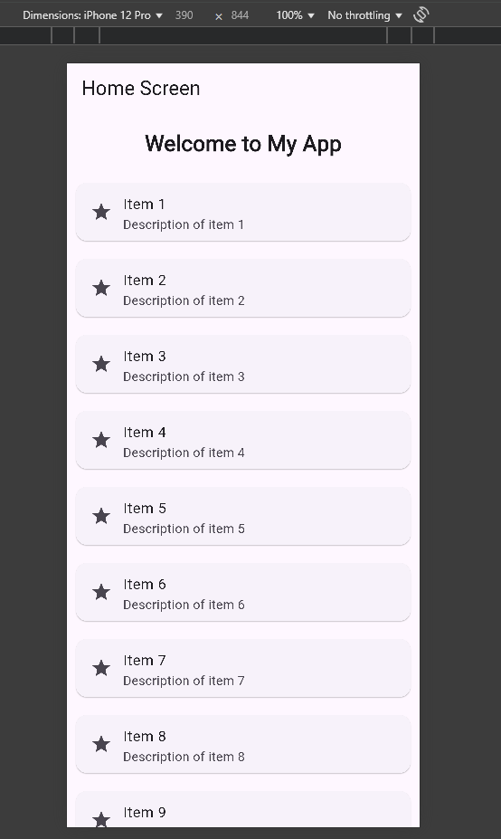

Screenshot of the application in small layout

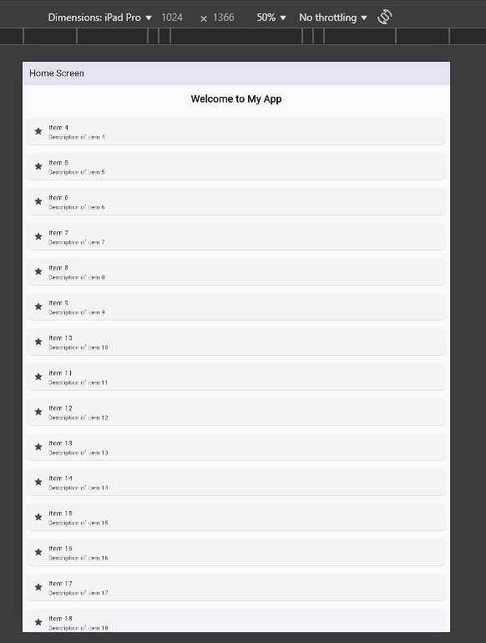

Screenshot of the medium layout

Изображение выглядит как текст, снимок экрана, программное обеспечение

Контент, сгенерированный ИИ, может содержать ошибки.

Screenshot of the wide screen layout

Adaptability & Responsiveness

The layout is designed to be responsive across different screen sizes and orientations by leveraging:

Expanded: Ensures the scrollable ListView takes up the remaining vertical space in the Column, making the layout adapt to screen height changes.

ListView.builder: Automatically enables vertical scrolling when the number of items exceeds the screen size, supporting both portrait and landscape modes.

Flexible Layout Widgets: Like Column, Container, and SizedBox to organize space with padding, spacing, and alignment.

Widgets & Techniques Used

MaterialApp & Scaffold: Provide the basic app structure with an app bar and body.

AppBar: Displays a consistent header across screen sizes.

Container: Adds padding and separates the title visually.

ListView.builder: Dynamically generates a scrollable list of cards.

Card + ListTile: Creates visually clean, structured items with icons and text.

Let me know if you want to convert it into a grid layout or add navigation/buttons!